1. Difference Between Frontend, Backend, and Full-Stack Development
Frontend | Backend | Full Stack
Works on the user interface (UI). | Handles server-side logic and databases. | Works on both frontend and backend.
Technologies: HTML, CSS, JavaScript, React | Technologies: Node.js, Java, Python, PHP | Uses frontend and backend technologies together.
Users interact directly with it. | Users cannot see it directly. | Develops complete web applications.
Real-world Example: Amazon
- Frontend: Product pages, buttons, search bar, cart.
- Backend: User login, payment processing, order management.
- Full Stack: Builds both frontend and backend to create the complete website.

2. Client-Server Model Diagram
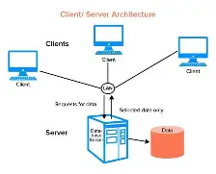
3. How a Browser Requests and Displays a Web Page
- User enters a website URL.
- Browser sends an HTTP request to the web server.
- The server processes the request.
- If required, the server fetches data from the database.
- The server returns HTML, CSS, and JavaScript files.
- The browser downloads these files.
- The browser renders the page and displays it to the user.

4. Tools Required for Web Development
Tool | Purpose
VS Code | Writing source code
Google Chrome | Testing web pages
Git | Version control
GitHub | Store projects online
Node.js | Run JavaScript outside browser
npm | Install packages
Live Server Extension | Live preview of web pages

5. What is a Web Server?
A web server is software or hardware that receives HTTP requests from clients (browsers) and sends web pages or data back to them.
Examples
- Apache HTTP Server
- Nginx
- Microsoft IIS
- Node.js Server
- LiteSpeed
6. Roles in a Web Development Project
Frontend Developer
- Designs website UI
- Creates responsive layouts
- Uses HTML, CSS, JavaScript, React
Backend Developer
- Writes server-side code
- Handles authentication
- Connects the database
- Builds APIs
Database Administrator (DBA)
- Designs database
- Maintains data security
- Creates backups
- Optimizes database performance

  - Install VS Code and Configure
 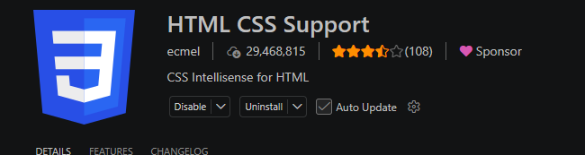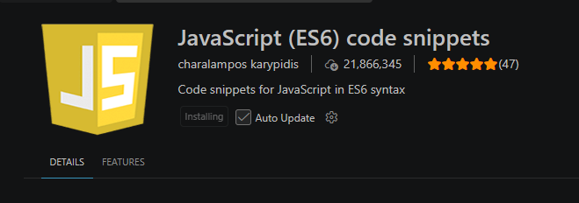

- 8. Difference Between Static and Dynamic Websites
Static Website | Dynamic Website
Fixed content | Content changes dynamically
No database | Uses database
Fast loading | Slightly slower
HTML, CSS | Node.js, PHP, Python, Java, Database
- Examples
- Static: Portfolio website
- Dynamic: Facebook, Amazon, Instagram
9. Five Web Browsers and Their Rendering Engines
Browser | Rendering Engine
Google Chrome | Blink
Microsoft Edge | Blink
Mozilla Firefox | Gecko
Safari | WebKit
Opera | Blink
Difference Between Rendering Engines
- Blink is fast and powers Chrome, Edge, and Opera.
- Gecko is Firefox's independent engine focused on web standards.
- WebKit is Apple's rendering engine used in Safari and optimized for Apple devices.

10. Basic Web Architecture Diagram
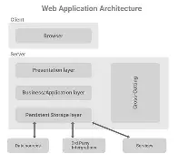
Conclusion
Web development consists of three major parts: Frontend, Backend, and Database. Browsers communicate with web servers using HTTP requests, servers process the requests, access databases or APIs if needed, and return responses that are displayed to users.

